<page_start no = 1>
<sol_start id=1>
1. Parallel beam of light
<sol_end>

<sol_start id=2>
2.
⇒ f = 25 cm
It will provide convex mirror as outward bulging surface of the sphere is to be used as mirror.
<sol_end>

<sol_start id=3>
3. 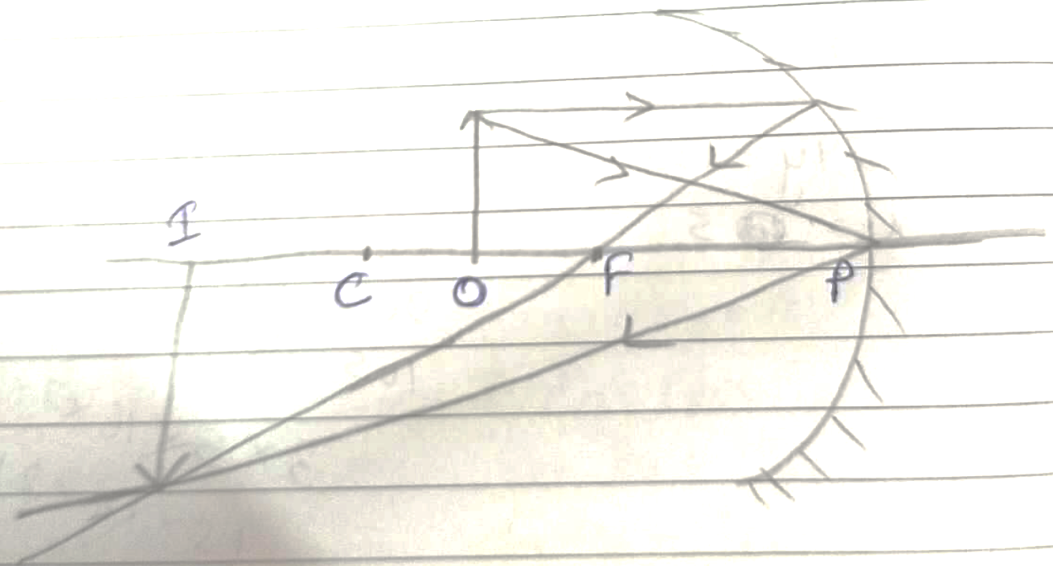
When the object is placed between C and f the image will be formed beyond C and would real, enlarged and inverted.
<sol_end>
<page_end>

<page_start no = 2>
<sol_start id=4>
4. height of object = 2 cm
f = 10 cm
u = 15 cm
∴ v = 30 cm
Image is formed at a distance of 30 cm from the mirror.
The image of the is diminished and it real and inverted.
<sol_end>
<page_end>

